Wildflower Resources

It is difficult to predict if and when wildflowers will bloom in the desert. Each year it takes the right combination of sun, wind, rain, and temperature to set the stage for the springtime bloom. Assuming the desert receives enough rain and warm (but not hot) temperatures, wildflowers generally bloom from late February through March. For up-to-date wildflower reports, check out the resources listed below.

General California Desert Wildflower Information
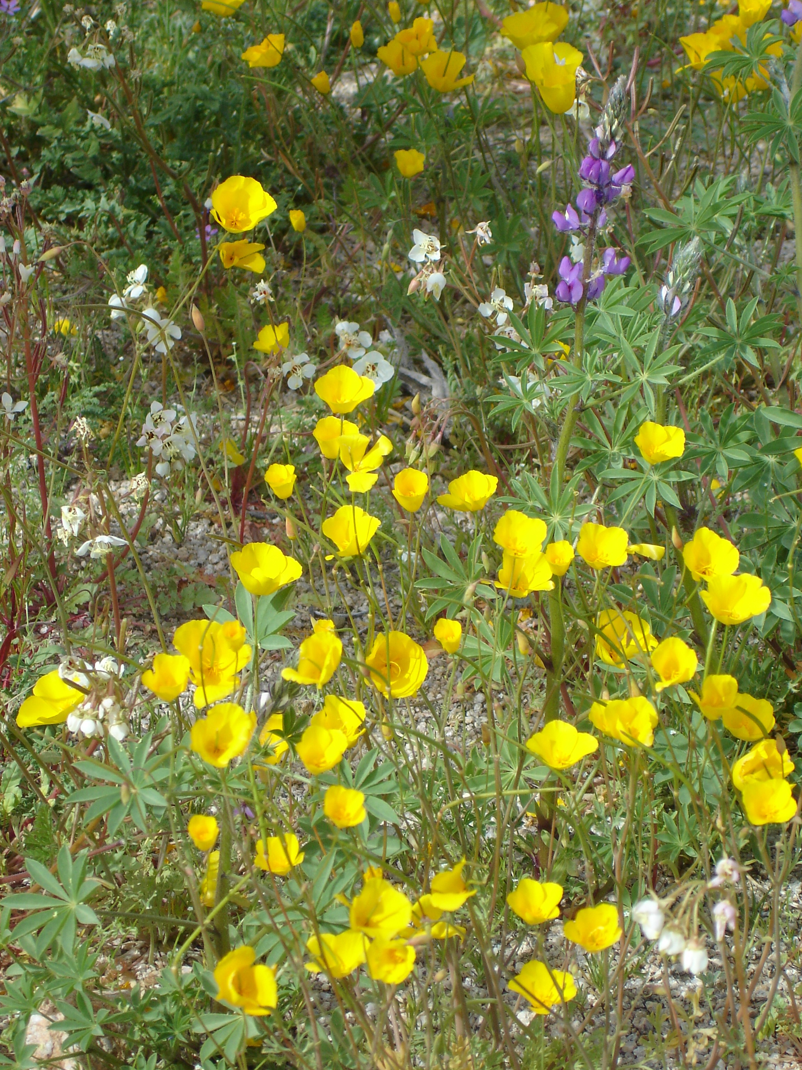
www.desertusa.com, then Click on the tab Guides, select Desert Wildflowers Guides, and choose the link of your choice.

Anza Borrego Desert State Park
theabf.org/explore-anza-borrego/wildflowers/
www.abdnha.org
Wildflower Hotline: 760-767-4684
Places to look for wildflowers in Anza Borrego Desert State Park include the Borrego Palm Canyon Trail and the Cactus Loop Nature Trail, and along Henderson Canyon Road off SR22 outside of Borrego Springs. Coyote Canyon is another great location but is a dirt road is best suited for trucks, SUVs, or similar vehicles.

Joshua Tree National Park
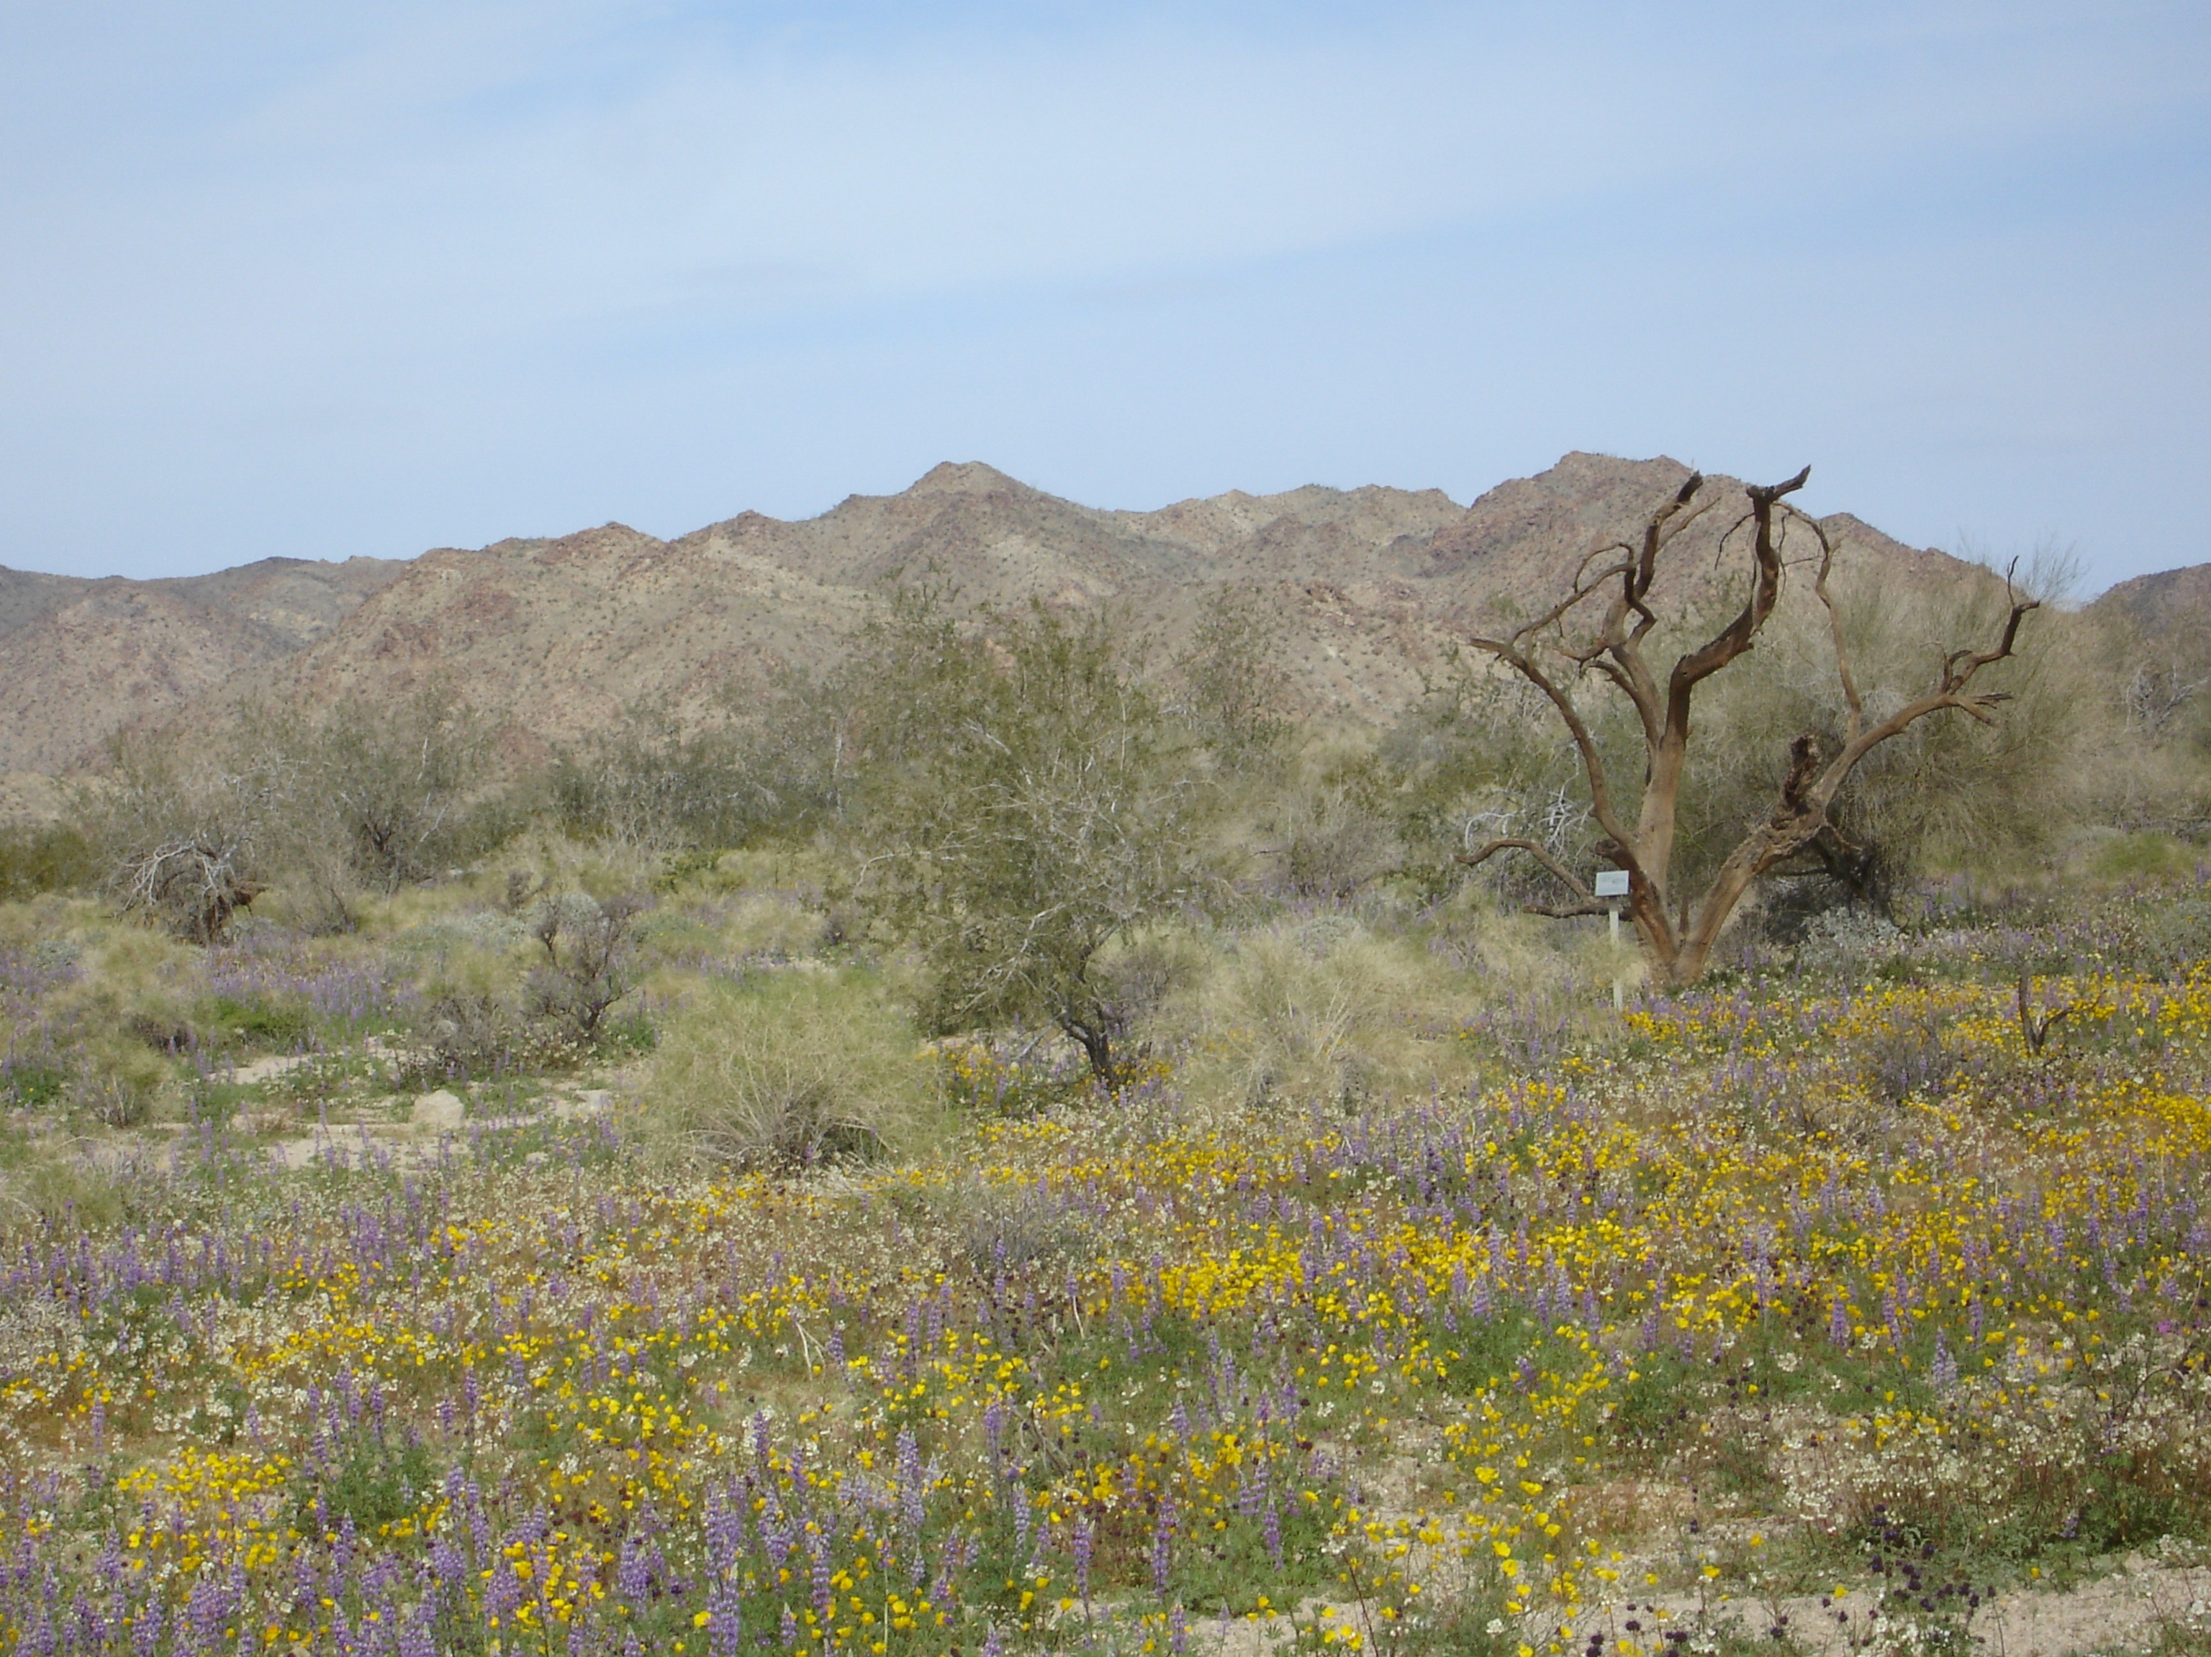
www.nps.gov/jotr/
Due to the variety of terrain in Joshua Tree National Park, the wildflower season there may last longer. Wildflowers may begin blooming in the lower elevations of the Pinto Basin and along the park’s south boundary (as shown in the picture on the right, taken at the Bajada Nature Trail) in February and at higher elevations in March and April. Desert regions above 5,000 feet may have plants blooming as late as June. The Joshua Trees themselves begin blooming at the end of February and continue through March in higher elevation areas.

Santa Rosa and San Jacinto Mountains National Monument
51500 Highway 74, Palm Desert
760-862-9984
The Friends of the Desert Mountains hosts an annual Coachella Valley Wildflower Festival on the first Saturday in March at Palm Desert Civic Center Park. Activities include a 5K Run/Walk, exhibitors, artist expo, a Kids’ Zone, live music and food and beverage for purchase. Friends of Desert Mountains also leads guided hikes during the tourist season. Call the Monument’s Visitor Center for the current schedule and additional details.

